Go to sql server download microsoft

Click on developer to download now

Go to download file location and double click on downloaded file to install it.

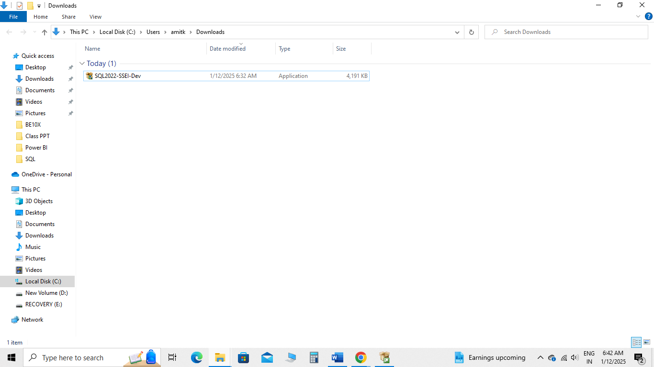

It will take 10 to 15 minutes to install this software

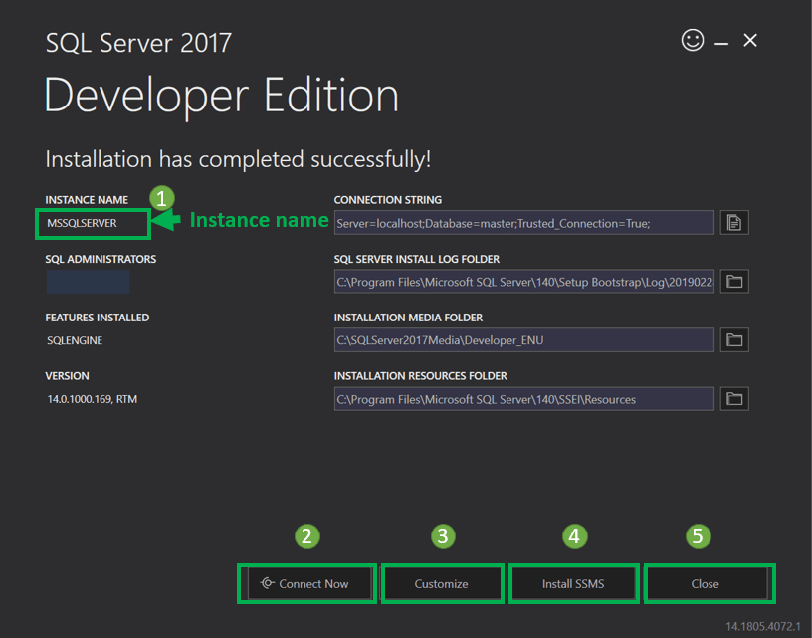

Click on install SSMS

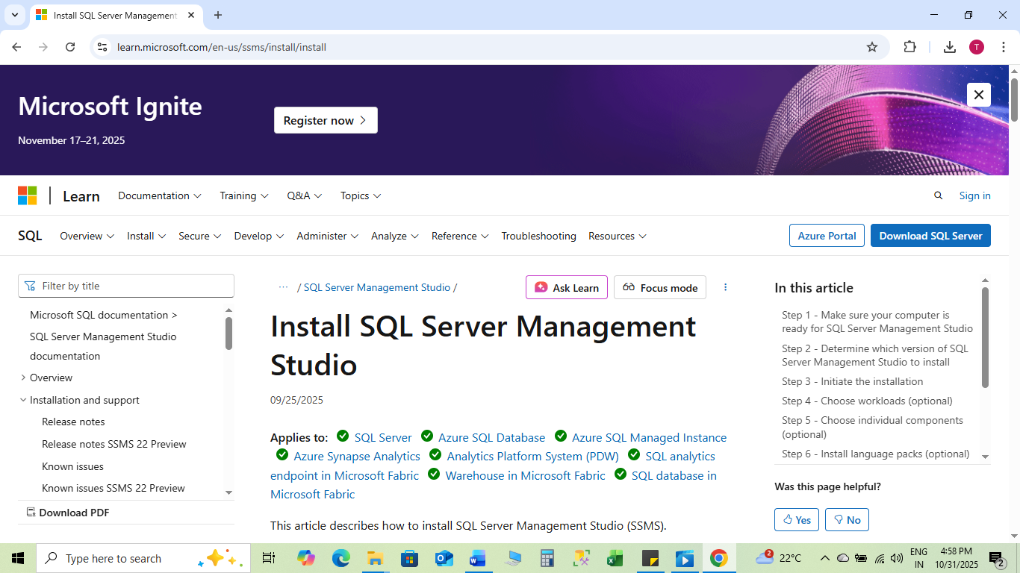

Click on Download SSMS 21

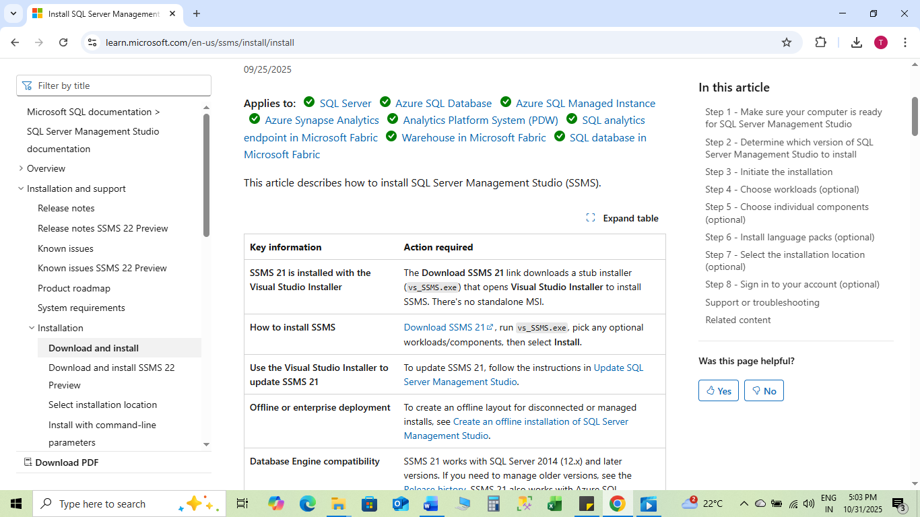



Install SSMS 21 Continue

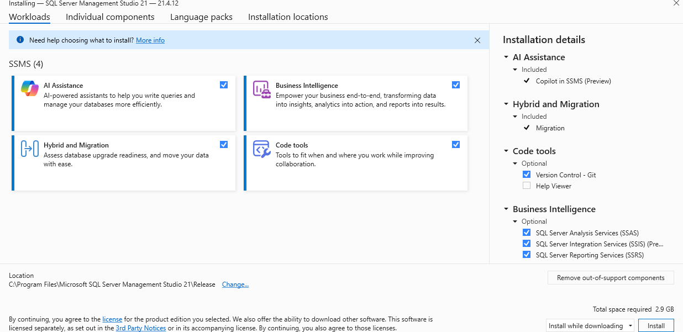

click on all 4 check box i.e. AI Assistance, Business Intelligence, Hybrid and Migration, Code tools

click on Install

click on OK (after installation done)

Go to search button in computer and search for SSMS , than click on “SQL Server Management Studio 21” , click on “Skip and add accounts later”

SQL Server will start

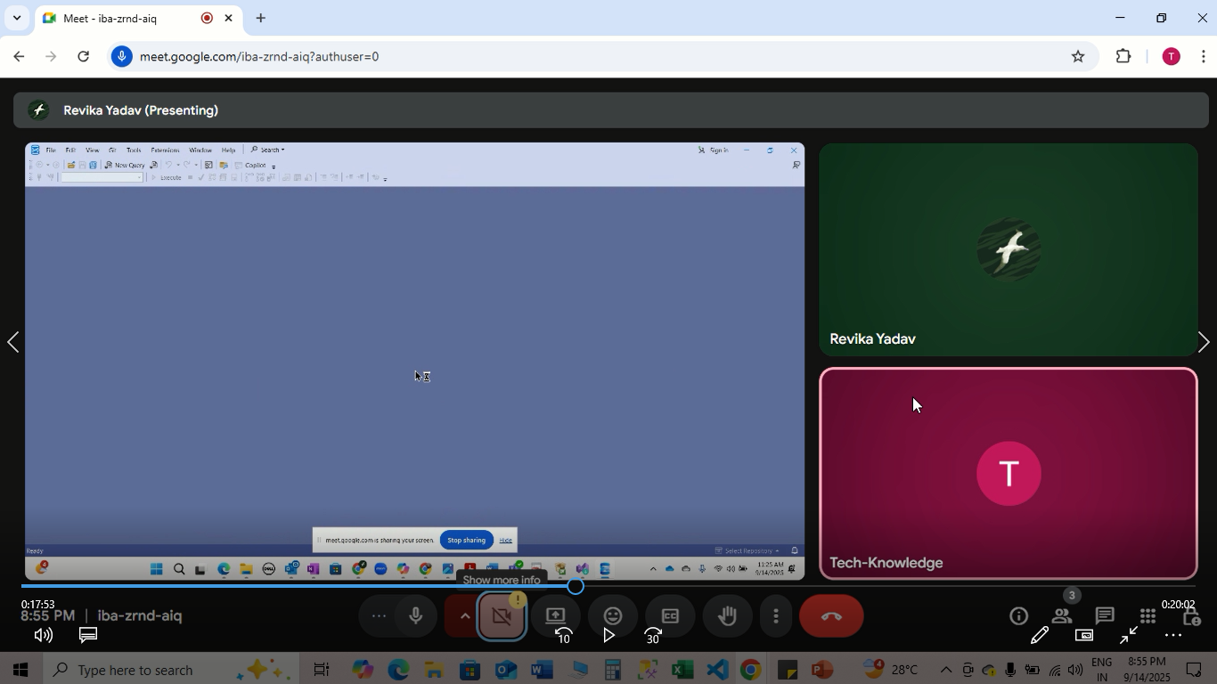

Click on yes

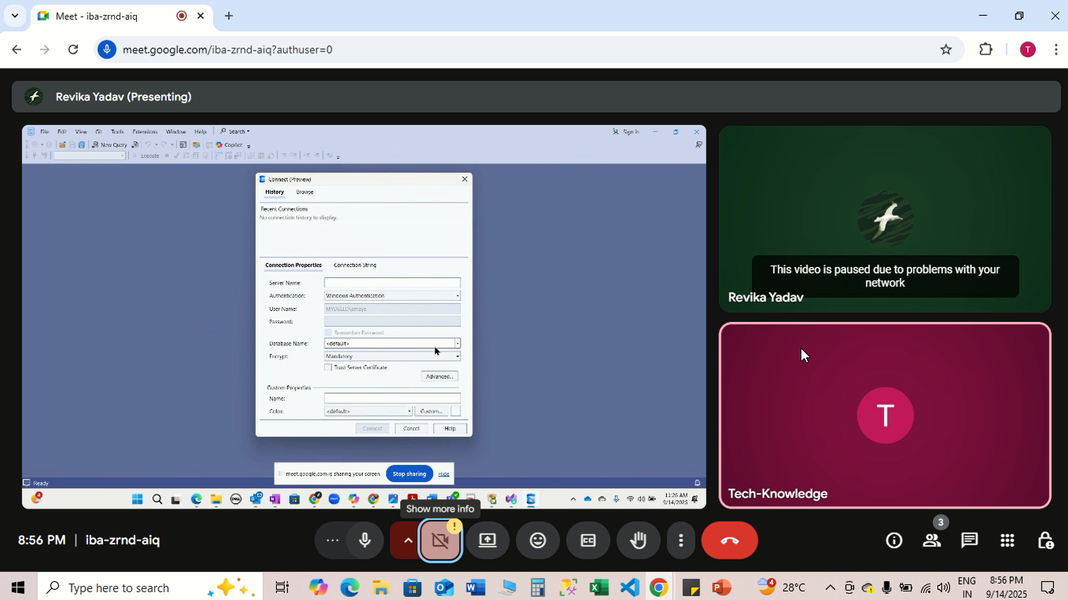

Go to search in computer and type “system information”

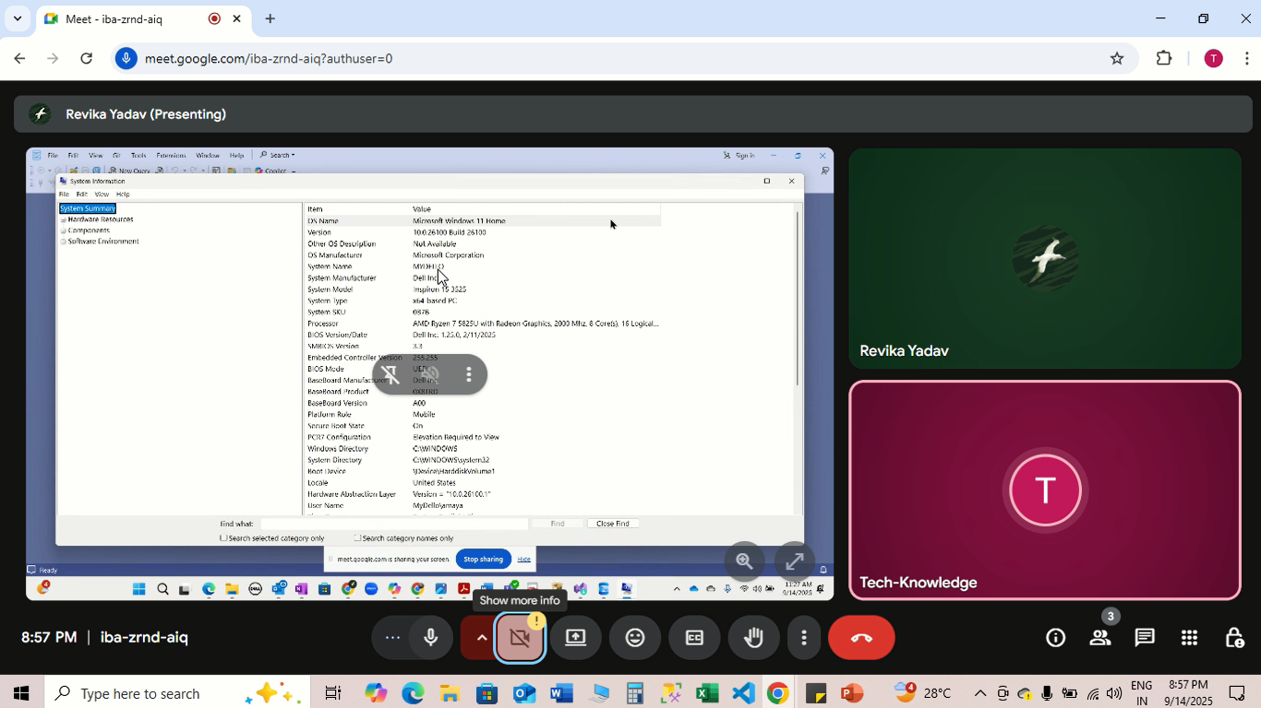

Copy the System Name or type System Name into Server name

And give backslash “\” above the enter button on keyboard

Example-DESKTOP-VF03L6Q\SQLDEVELOPER



System name



Click on Check box at “Trust server certificate” and click on “Connect”

Authentication: “Windows Authentication”

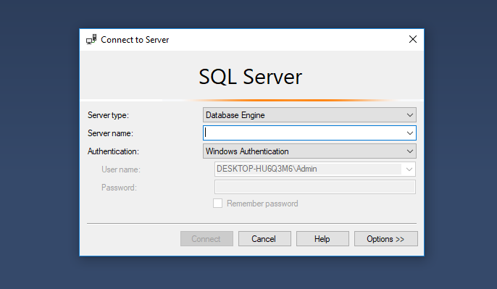

You will get SQL Server

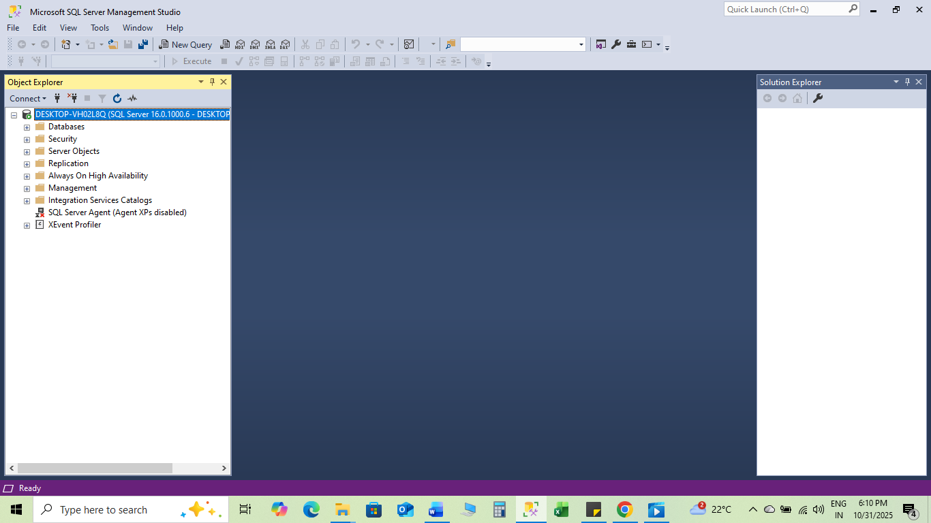

Also create a short cut icon for it by clicking right click on “SQL Server Management Studio 21” in search button